**4COSCO11C.2 Web Design and Development**

**Tutorial 4**

### Task 1 - Create your Web Page content

Create a file and save it as **tutorial4.html**

Your page will have a html form applied to the following subjects.

* Hotel reservation - if **your surname** starts with the one of following letters: **Q,W,E,R,T,Y,U,I,O,P**
* University Registration - if **your surname** starts with **A,S,D,F,G,H,J,K, or L**
* Bank account details - if **your surname** starts with **Z,X,C,V,B,N or M**

Then follow this specification to create a form where users will be able to enter their details.

1. Align the form controls using CSS float (by styling label tags).
   * If using CSS float, use **explicit html form labels**for CSS float and to improve accessibility.
2. You can use fieldsets (with legend) to separate different parts of the form. Then use CSS to style the fieldset and legends.
3. Include all the following form controls appropriately.
   1. Input type: text
   2. HTML5 <input type="email">.
      * Make sure that you understand the functionality that this input type provides. E.g., what is the format of an acceptable email?
   3. Input type: password
   4. Input type: radio
   5. Textarea.
   6. A select type (either a pop up list or scrolling list).
   7. A single checkbox for "terms and conditions".
   8. A form control to reset the form.
   9. A form control to submit the form data.
4. Check that only **one set of <form> tags**are used to enclose all of your form controls.
5. Then include the following **HTML5** attributes.
   * Use the *placeholder* attribute in an <input type="text"> control. Compare it with the older *value* attribute.
   * For the checkbox "terms and conditions" use the *required*attribute so that it is mandatory for it to be checked.

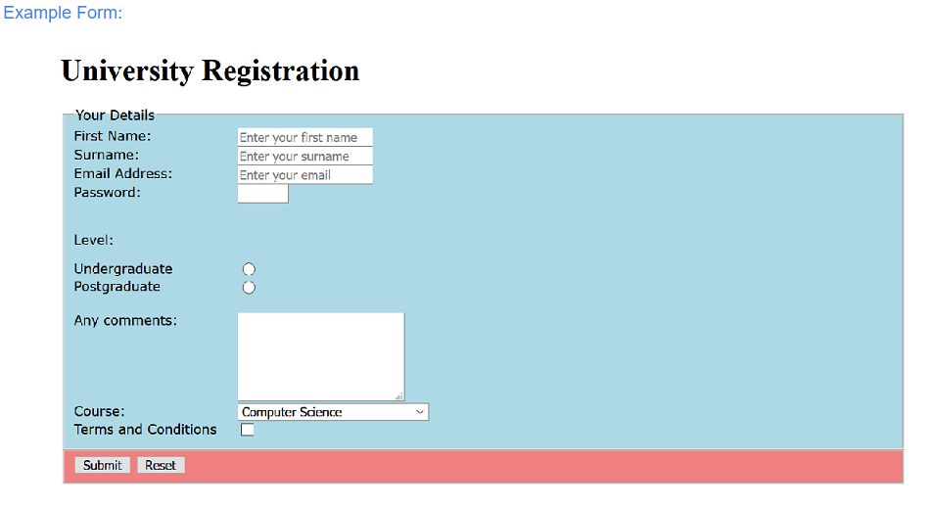

Task 2 - Complete the Tutorial Test on Blackboard

* Go to Assessment -> Tutorial Tests -> HTML Forms Test and complete the test. You can have up to five attempts to get the maximum score of 2 marks.